EXPERIMENT 4:
CODE4(a): Smoothing by Bin Mean
# Data
x <- c(11,13,13,15,15,16,19,20,20,20,21,21,22,23,24,
30,40,45,45,45,71,72,73,75)

# Divide into bins of size 3
bins <- split(x, ceiling(seq_along(x)/3))

# Bin Mean
bin_mean <- lapply(bins, function(b) rep(mean(b), length(b)))

cat("Smoothing by Bin Mean:\n")
print(unlist(bin_mean))
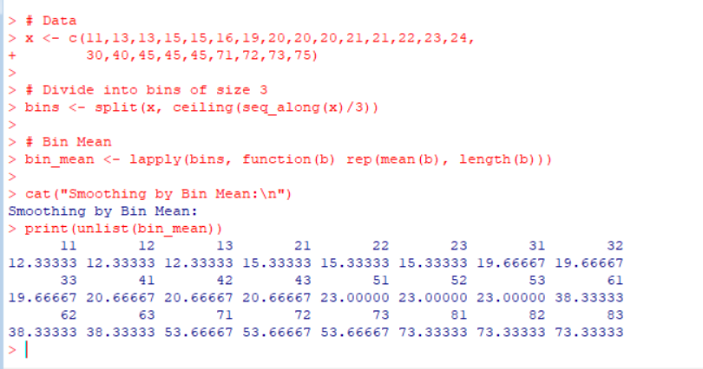

CODE4(B):
# Data
x <- c(11,13,13,15,15,16,19,20,20,20,21,21,22,23,24,
30,40,45,45,45,71,72,73,75)

bins <- split(x, ceiling(seq_along(x)/3))

# Bin Median
bin_median <- lapply(bins, function(b) rep(median(b), length(b)))

cat("Smoothing by Bin Median:\n")
print(unlist(bin_median)) # Data
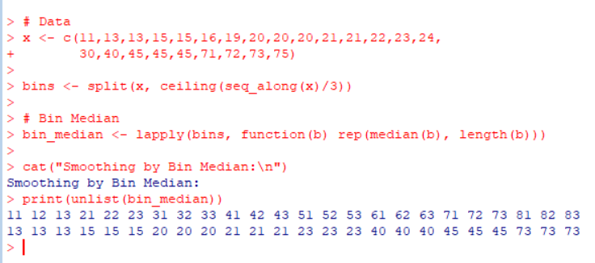

CODE4(C):

# Data
x <- c(11,13,13,15,15,16,19,20,20,20,21,21,22,23,24,
30,40,45,45,45,71,72,73,75)

bins <- split(x, ceiling(seq_along(x)/3))

# Bin Boundaries
boundary <- lapply(bins, function(b){
low <- min(b)
high <- max(b)
sapply(b, function(v){
if((v-low) <= (high-v))
low
else
high
})
})

cat("Smoothing by Bin Boundaries:\n")
print(unlist(boundary))

